**Bond Analysis**

**Research Question**

Considering current bond metrics (risk vs. return parameters) which would be the optimal bucket to go long when adding duration?

**Executive Summary**

Utilizing prevailing bond yields and price sensitivities, we determined the Sharpe Ratio of specific bonds across the SA Govi curve. The bonds selected ranged from 1 year (Treasury-Bills) to 30 years (R2053 bond) and were used as proxies for various maturity buckets along the curve.

In addition, the calculated Sharpe Ratio measured the excess return of each bond over the current SA Repo Rate (8.25%) relative to its risk or Rand Per Basis Point (RPBP[1]).

Our analysis shows that given current bond yields and risk numbers, the 20-year bucket (represented by the R2044 bond) produced the highest Sharpe Ratio and consequently the optimal risk adjusted return from the Govi bonds considered.



Final Thoughts

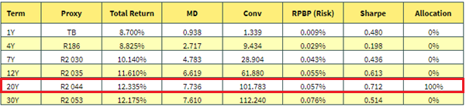

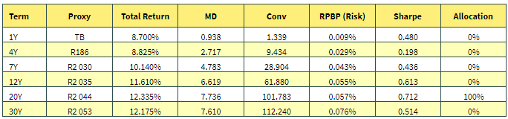

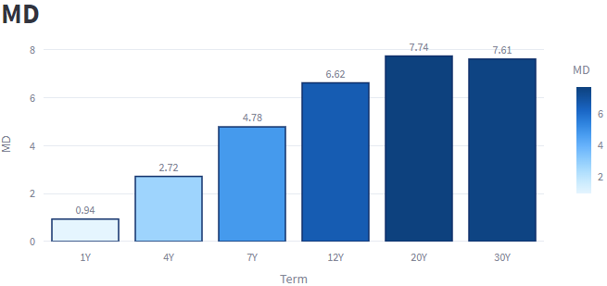

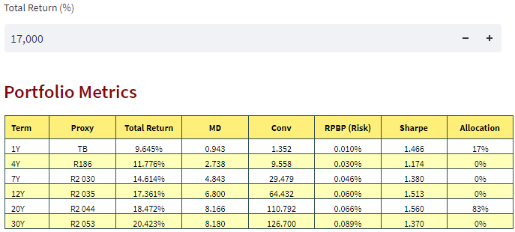

1. The RPBP gauges the change in bond price for a one basis point change in yield (∆y). The price difference is approximated using the bonds Modified Duration (MDur) and Convexity (Conv) measures as shown below:

   **∆P = (-MDur) x P x ∆y + $\frac{1}{2}$ x (Conv) x (∆y)2**